|  |  |
| --- | --- |
| **McGill University**  **MATH 240 - Discrete Structures** | **Fall 2011**  **Prof Sergey Norin** |

# propositional Logic

#### Proposition

Def: a statement (sentence) that is either true or false

Samples:

2 + 2 = 4 → true PROP.

2 + 3 = 7 → false PROP.

“If it will be sunny tomorrow” PROP.

“What is going on?” NOT

“Stop at the red light” NOT

## LOGICAL symbols

**⇒, →, ⊃**

Implication

*A* ⇒ *B* means if *A* is true then *B* is also true

implies; if .. then

**⇔, ≡, ↔**

Equivalence

A ⇔ B means A is true if and only if B is true.

if and only if; iff

**¬**

Negation

¬A is true if and only if A is false.  
not

**∧, &**

Conjunction

A ∧ B is true if *A* and *B* are both true; else it is false

**∨, ǀǀ**

Disjunction

A ∨ B is true if *A* or *B* (or both) are true

**⊕**

Exclusive disjunction

A ⊕ B is true when either A or B, but not both,

are true.

**⊤, T, 1**

Tautology

T is unconditionally true

A ⇒ T is always true.

**⊥, F, 0**

Contradiction

⊥ is unconditionally false

⊥ ⇒ A is always true

Quantifiers

$$∀$$

“For all”

Chain of conjunctions: p1 ∧ p2 ∧ p3 ∧ …

“There exists”

Disjunctions: p1 ∨ p2 ∨ p3 ∨ …

## Truth tables

We say that two statements are **equivalent** if their corresponding truth tables are the same.

¬(¬*p*∨¬*q*)≡*p*∧*q*

|  |  |  |  |  |  |
| --- | --- | --- | --- | --- | --- |
| p | q | ¬ p | ¬q | ¬*p*∨¬*q* | ¬(¬*p*∨¬*q*) |
| T | T | F | F | F | T |
| T | F | F | T | T | F |
| F | T | T | F | T | F |
| F | F | T | T | T | F |

## Rules of logic

Like Set theory.

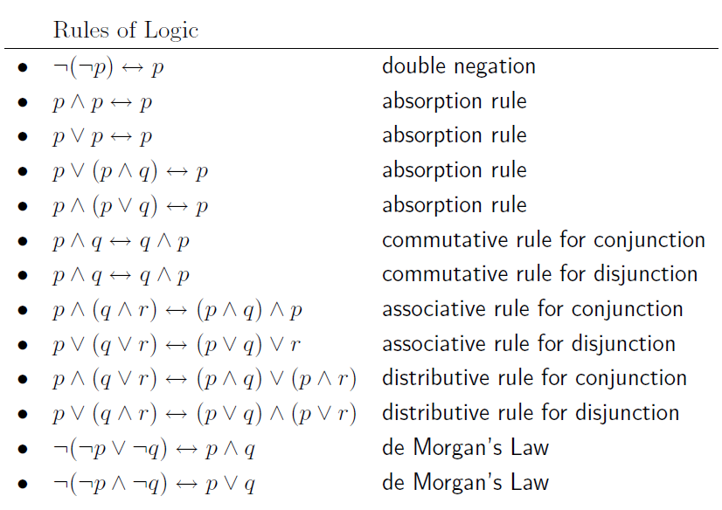

Idempotent Rules: p ∧ p ≡ p ≡ p ∨ p

De Morgan Law : ┐(p ∧ q) = ┐p v ┐q

Tautology and contradiction properties  
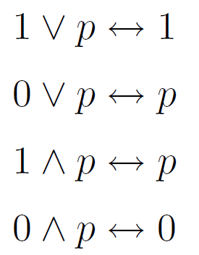

┐p ∨ p <-> 1

┐p ∧ p <-> 0

#### Logical properties

(p -> q) <-> ( ┐p V q)

(p -> q) <-> ( ┐p) -> ( ┐q)

(p -> q) ∧ (q->p) <-> ( p <-> q)

(p->q) ∧ (q->r) -> (p->r)

Implication is transitive. p -> q -> r <-> (p -> r)

┐( $∀$ n ( p(n) )) <-> $∃$ n ( ┐p(n) )

*Example: The negation of  is .*

## Conditional and biconditional statements

“If p then q”

↔ “If an assumption holds then the conclusion holds”

↔“p implies q”

|  |  |
| --- | --- |
|  | Is p->q a true implication…  if p is false and q false? Yes  if p is false and q true? Yes  **if p is true and q is false? No**  if p is false and q is false? Yes |

NB:

If q is true, then p-> q is automatically true.

If q is false, then p-> q is true only if p is false too.

NB:

*p* -> *q* can be false only if the guarantee that whenever *p* is true then *q* is true is violated.

## Proofs

Proof : Sequence of valid implications (p) that give the conclusion q.

#### Types of proofs

**Direct Proof**

*p*1→*p*2→...→*pk*→*q*

**Proof by contradiction**

(*p*→*q*) ↔ ((¬*p*)→(¬*q*))

**By contradiction with the Well-Ordering principle**

Every non empty subset of non-negative integers has a smallest element.

P(n) is true for all position integers n>n0

1. C = {n Є N| P(n) is false} and non-empty.
2. By WO principle, n0 is smallest element in C.
3. Obtain contradiction for n0

Example: n0 C

**Case Analysis**

(*p*∨*q*→*r*) ↔ (*p*→*r*)∧(*q*→*r*)

**Counter Example**

Only one counter example is enough

**Induction**

P(n) is true for all natural integers n>n0

1. Base case: Show that P(n) is true for b0
2. Induction step:

I.H.: P(n) is true.

Show that P(n+1) is true .

#### Equivalence relationship

To prove (p <-> q): prove (p->q)∧(q->p).

#### Proving logic rules

Use direct proofs

* Use the basic set identities (Rosen, p. 89)
* Use membership tables
* Prove each set is a subset of each other (equivalence relationship).
* Use set builder notation and logical equivalences